Addressing in Computer Networks

Tatu Bogdan – Gr. 3.1

1. 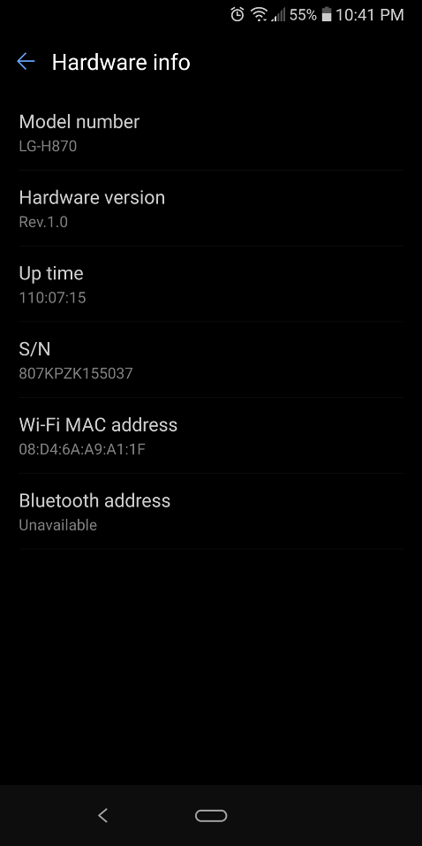Phone MAC Address: 08:D4:6A:A9:A1:1F
2. 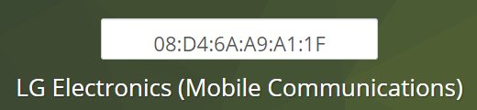Phone’s NIC Manufacturer: LG Electronics
3. 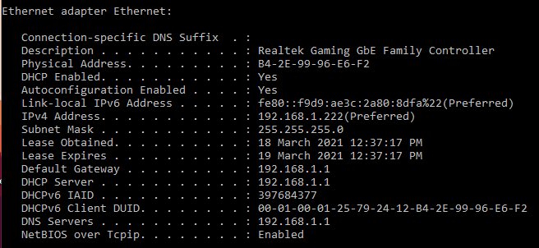PC’s MAC Address: B4:2E:99:96:E6:F2
4. 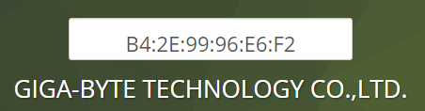PC’s NIC Manufacturer: GIGA-BYTE
5. Individual Part: 96:e6:f2 ( last 3 bytes of MAC address )
6. 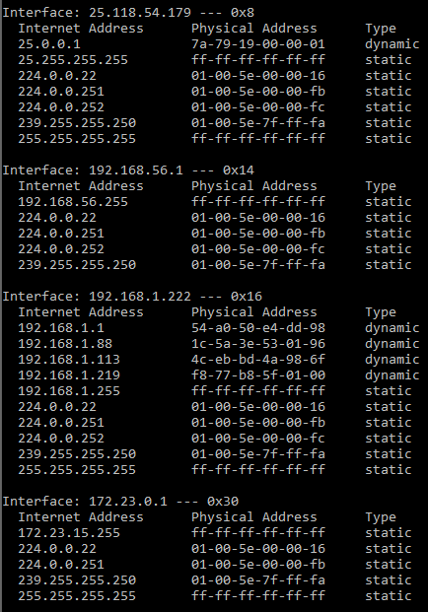ARP Table Entries:
7. Frame 42:

|  |  |  |  |  |  |
| --- | --- | --- | --- | --- | --- |
| MAC Dest | MAC Src | IP Scr | IP Dest | Transport Header | Data |
| B4:2E:99:96:E6:F2 | 54:A0:50:E4:DD:98 | 162.159.133.234 | 192.168.1.222 | - | - |

1. 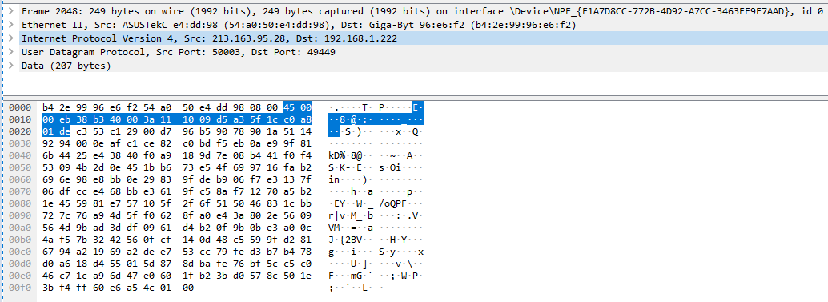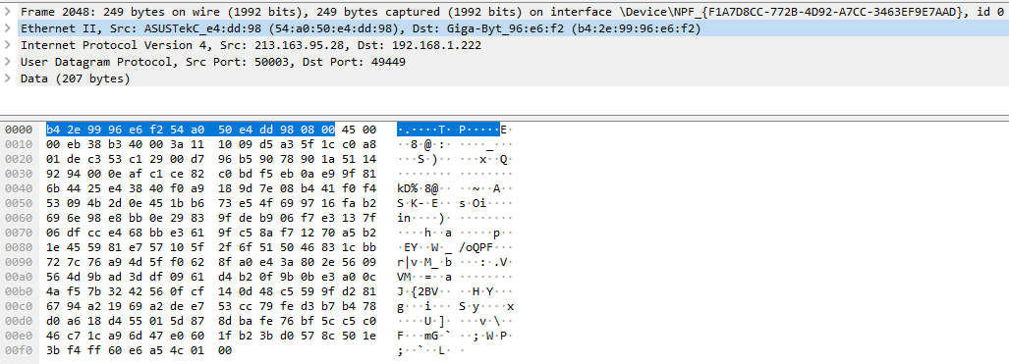Frame 2048: Physical then Logical Addresses
2. 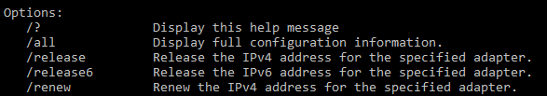ipconfig vs ipconfig /all: Shows more details, such as the physical address.

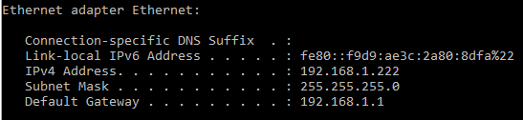ipconfig

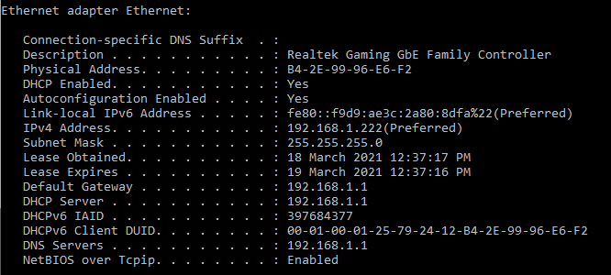ipconfig /all

1. IPv6 Addresses:
   * PC MAC: B4:2E:99:96:E6:F2
   * PC IPv6: B6:2E:99:FF:FE:96:E6:F2
   * Phone MAC: 08:D4:6A:A9:A1:1F
   * Phone IPv6: 0A:D4:6A:FF:FE:A9:A1:1F